MODULE 4 – INTRODUCTION TO DBMS

LAB EXERCISES

23. Rollback and Commit Savepoint
Lab 1.
Perform a transaction that includes inserting a new members, setting a SAVEPOINT, and rolling back to the savepoint after making updates.
Ans.
1. START TRANSACTION;

INSERT INTO members_backup(member_name, date_of_membership, email) VALUES ('Sneha Patel', '2026-03-09', 'sneha@gmail.com');

SAVEPOINT after_insert;

UPDATE members_backup SET email = 'updated_email@gmail.com' WHERE member_id = 2;

ROLLBACK TO SAVEPOINT after_insert;

COMMIT;

SELECT * FROM members_backup;

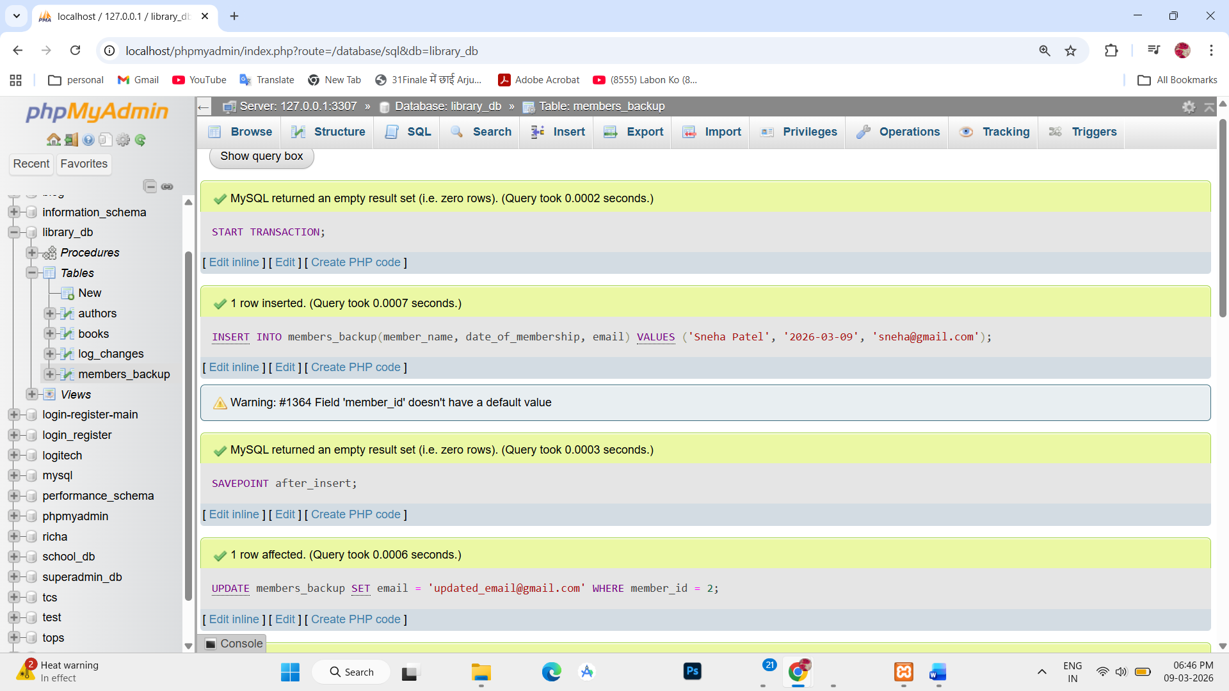

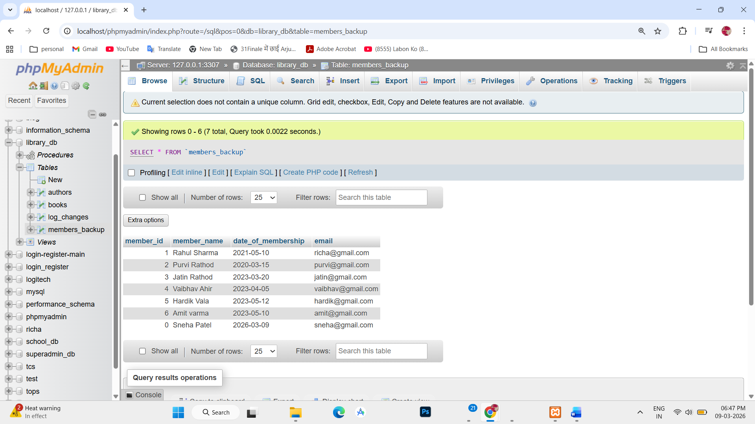

Lab 2.
Use COMMIT after successfully inserting multiple books into books table, then use ROLLBACK to undo a set of changes made after a savepoint.
Ans.
1. INSERT INTO books (title, author, publisher, year_of_publication, price, genre)
VALUES
('Python Basics', 'Alice', 'TechPub', 2022, 45, 'Programming'),
('Data Science 101', 'Bob', 'DataPress', 2021, 60, 'Data Science'),
('Machine Learning', 'Charlie', 'AI Books', 2023, 75, 'AI');
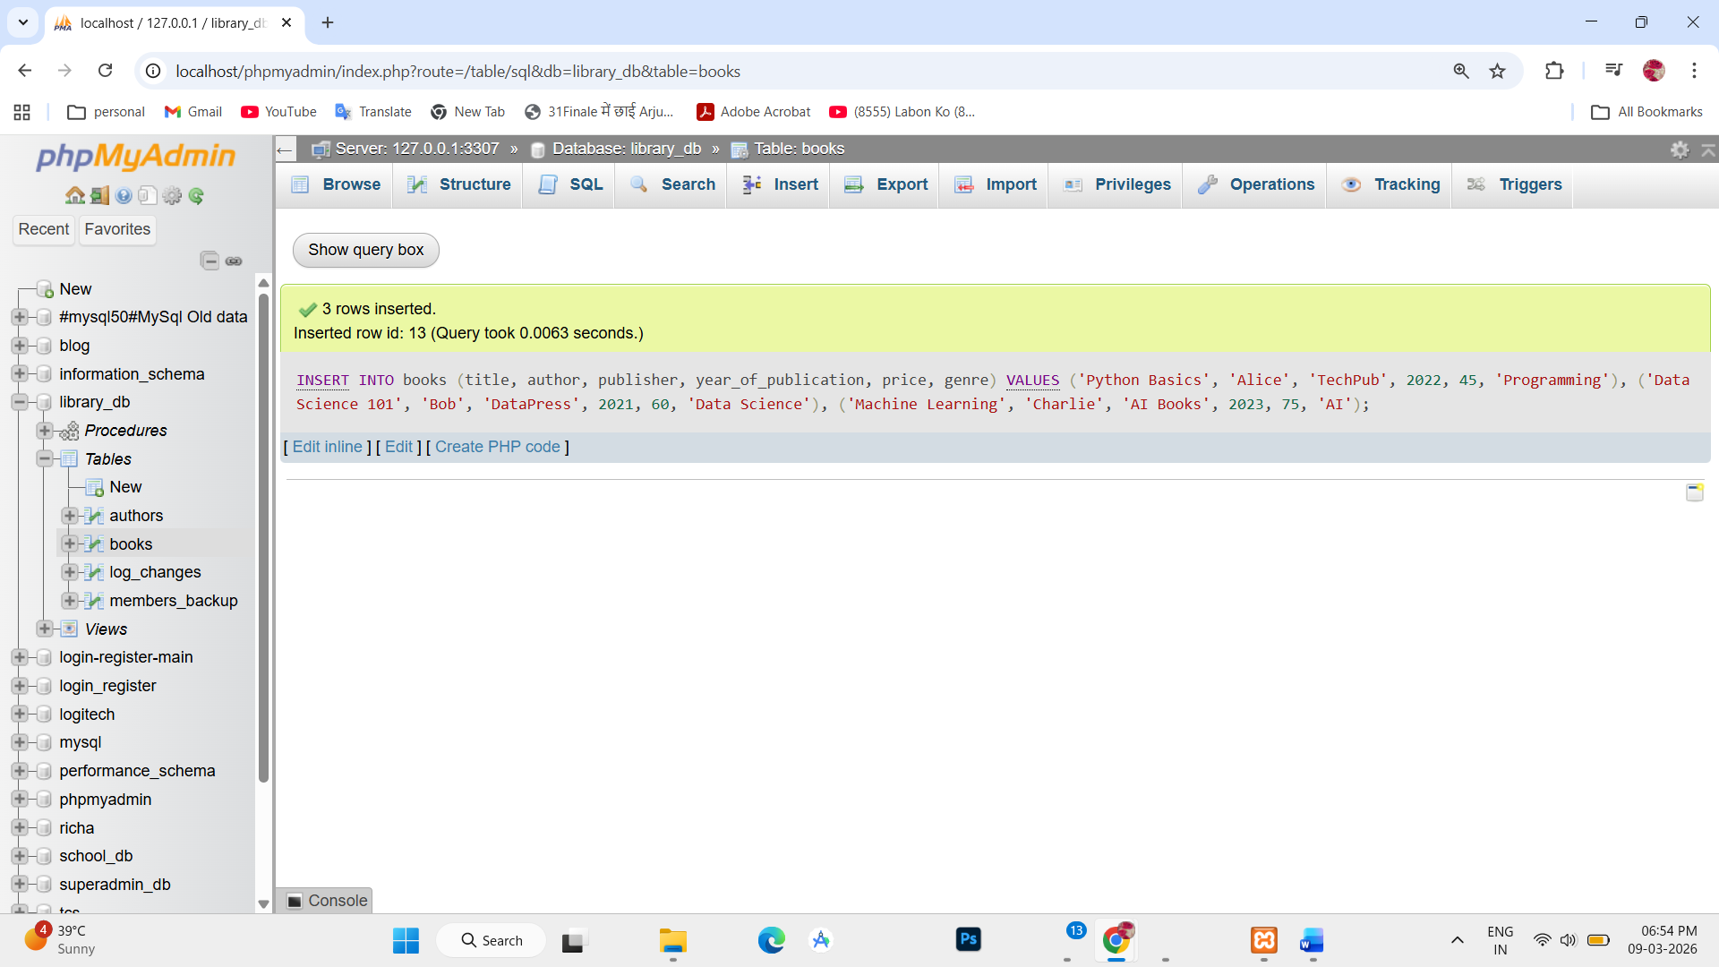

2. START TRANSACTION;

INSERT INTO books (title, author, publisher, year_of_publication, price, genre) VALUES
('Python Basics', 'Alice', 'TechPub', 2022, 45, 'Programming'),
('Data Science 101', 'Bob', 'DataPress', 2021, 60, 'Data Science'),
('Machine Learning', 'Charlie', 'AI Books', 2023, 75, 'AI');

COMMIT;
